Trabalho pratico nº3

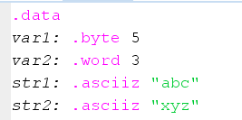3.1 a

3.1b

|  |  |  |
| --- | --- | --- |
| label | endereço | valor |
| Var1 | 0x010010000 | 0x00000005 |
| Var2 | 0x010010004 | 0x00000003 |
| Str1 | 0x010010008 | 0x00636261 |
| Str2 | 0x01001000c | 0x007a7978 |

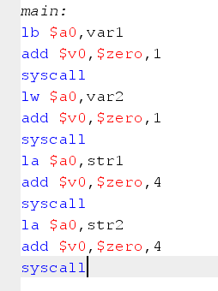3.1c

3.2 a

La significa endereço de carregamento. Ele pode ser usado para carregar constantes inteiras como li.

3.2b

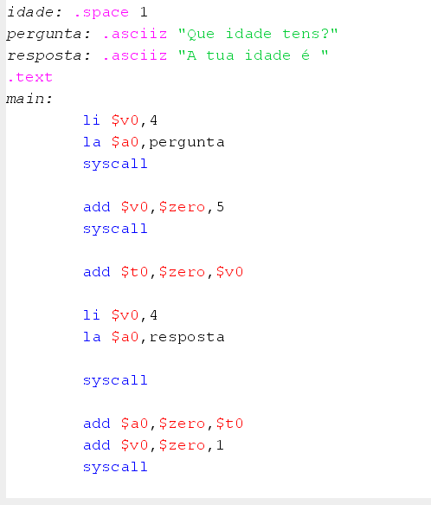

3.3

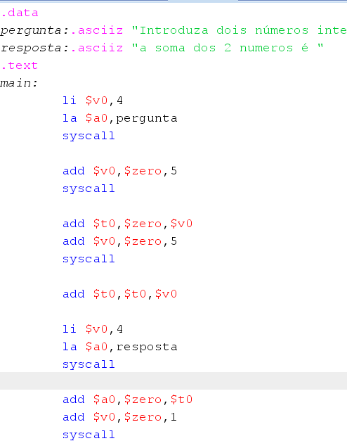

4.1a

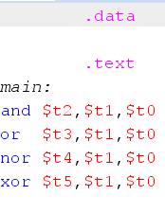

4.1be c

|  |  |  |  |  |  |
| --- | --- | --- | --- | --- | --- |
| $t0 | $t1 | $t2 | $t3 | $t4 | $t5 |
| 0x12345678 | 0x0000000F | 0x00000008 | 0x1234567f | 0xedcba980 | 0x12345677 |
| 0x12345678 | 0x000FF000 | 0x00450000 | 0x123ff678 | 0xedc00987 | 0x123ba678 |
| 0x762A5C1B | 0x89D5A3E4 | 0x00000000 | 0xffffffff | 0x00000000 | 0xffffffff |

4.1d

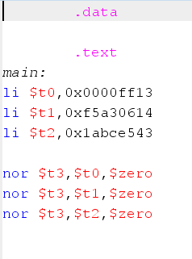

4.2 A e B

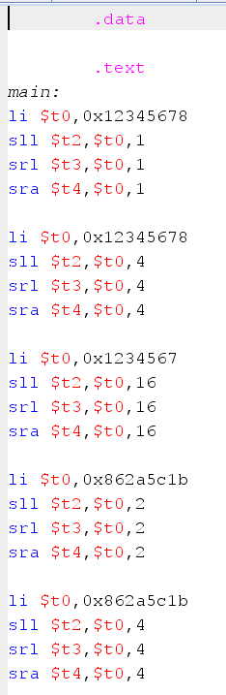

4.2C

|  |  |  |  |  |
| --- | --- | --- | --- | --- |
| $t0 | Imm | $t2 | $t3 | $t4 |
| 0x12345678 | 1 | 0x2468acf0 | 0x09la2b3c | 0x09la2b3c |
| 0x12345678 | 4 | 0x23456780 | 0x01234567 | 0x01234567 |
| 0x12345678 | 16 | 0x45670000 | 0x00000123 | 0x00000123 |
| 0x862A5C1B | 2 | 0x18a9706c | 0x218a9706 | 0xe18a97066 |
| 0x862A5C1B | 4 | 0x62a5clb0 | 0x0862a5cl | 0xf862a5cl |

4.2d não entendi o exercício